**Project Design Phase-I**

**Solution Architecture**

|  |  |
| --- | --- |
| Date | 14 October 2022 |
| Team ID | PNT2022TMID36166 |
| Project Name | Classification Of Arrhythmia By Using Deep Learning With 2-D ECG Spectral Image Representation |
| Maximum Marks | 4 Marks |

**Solution Architecture:**

The image is fed into the model that is trained and the cited class will be displayed on the webpage. We can also able to see the results. There are several types of arrhythmia including atrial fibrillation, premature contraction, ventricular fibrillation, and tachycardia.

* Although a single arrhythmia heartbeat may not have a serious impact on life, continuous arrhythmia beats can result in fatal circumstances.
* In this project, we build an effective electrocardiogram (ECG) arrhythmia classification method using a convolutional neural network (CNN).
* In which we classify ECG into seven categories, one being normal and the other six being different types webpage of arrhythmia using deep two-dimensional CNN with grayscale ECG images.
* The image is fed into the model that is trained and the cited class will be displayed on the

**Solution Architecture Diagram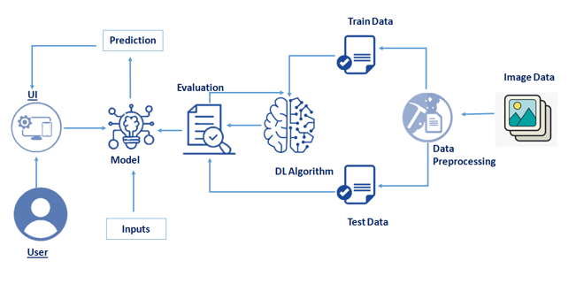:**

**Example Architecture Diagram (Refer):**

